|  |
| --- |
| **LAPORAN PRAKTIKUM JARINGAN KOMPUTER**  **3.5.5**  **PACKET TRACER – CONFIGURE DTP** |
|  |
| **Agus Pranata Marpaung**  **13323033**  **DIII TEKNOLOGI KOMPUTER** |
| **INSTITUT TEKNOLOGI DEL**  **FAKULTAS VOKASI** |

**Judul Praktikum**

|  |  |  |
| --- | --- | --- |
| **Minggu/Sesi** | : | XI/2 |
| **Kode Mata Kuliah** | : | 4332101 |
| **Nama Mata Kuliah** | : | JARINGAN KOMPUTER |
| **Setoran** | : | Jawaban dalam bentuk *softcopy* |
| **Batas Waktu Setoran** | : | *?* |
| **Tujuan** | : | 1. Mahasiswa mampu mengamankan perangkat jaringan dan memecahkan masalah pada konektivitas setiap perangkat. |

**Petunjuk**



**Packet Tracer - Configure DTP**

**Addressing Table**

|  |  |  |  |
| --- | --- | --- | --- |
| **Device** | **Interface** | **IP Address** | **Subnet Mask** |
| PC1 | NIC | 192.168.10.1 | 255.255.255.0 |
| PC2 | NIC | 192.168.20.1 | 255.255.255.0 |
| PC3 | NIC | 192.168.30.1 | 255.255.255.0 |
| PC4 | NIC | 192.168.30.2 | 255.255.255.0 |
| PC5 | NIC | 192.168.20.2 | 255.255.255.0 |
| PC6 | NIC | 192.168.10.2 | 255.255.255.0 |
| S1 | VLAN 99 | 192.168.99.1 | 255.255.255.0 |
| S2 | VLAN 99 | 192.168.99.2 | 255.255.255.0 |
| S3 | VLAN 99 | 192.168.99.3 | 255.255.255.0 |

**Objectives**

* Configure static trunking
* Configure and Verify DTP

**Background / Scenario**

As the number of switches in a network increases, the administration necessary to manage the VLANs and trunks can be challenging. To ease some of the VLAN and trunking configurations, trunk negotiation between network devices is managed by the Dynamic Trunking Protocol (DTP), and is automatically enabled on Catalyst 2960 and Catalyst 3650 switches.

In this activity, you will configure trunk links between the switches. You will assign ports to VLANs and verify end-to-end connectivity between hosts in the same VLAN. You will configure trunk links between the switches, and you will configure VLAN 999 as the native VLAN.

**Instructions**

**Part 1: Verify VLAN configuration.**

Verify the configured VLANs on the switches.

1. On S1, go to privileged EXEC mode and enter the **show vlan brief** command to verify the VLANs that are present.

*Open configuration window*

S1# **show vlan brief**

VLAN Name Status Ports

---- -------------------------------- --------- -------------------------------

1 default active Fa0/1, Fa0/2, Fa0/3, Fa0/4

Fa0/5, Fa0/6, Fa0/7, Fa0/8

Fa0/9, Fa0/10, Fa0/11, Fa0/12

Fa0/13, Fa0/14, Fa0/15, Fa0/16

Fa0/17, Fa0/18, Fa0/19, Fa0/20

Fa0/21, Fa0/22, Fa0/23, Fa0/24

Gig0/1, Gig0/2

99 Management active

1. Native active

1002 fddi-default active

1003 oken-ring-default active

1004 fddinet-default active

1005 trnet-default active

**Answer:**

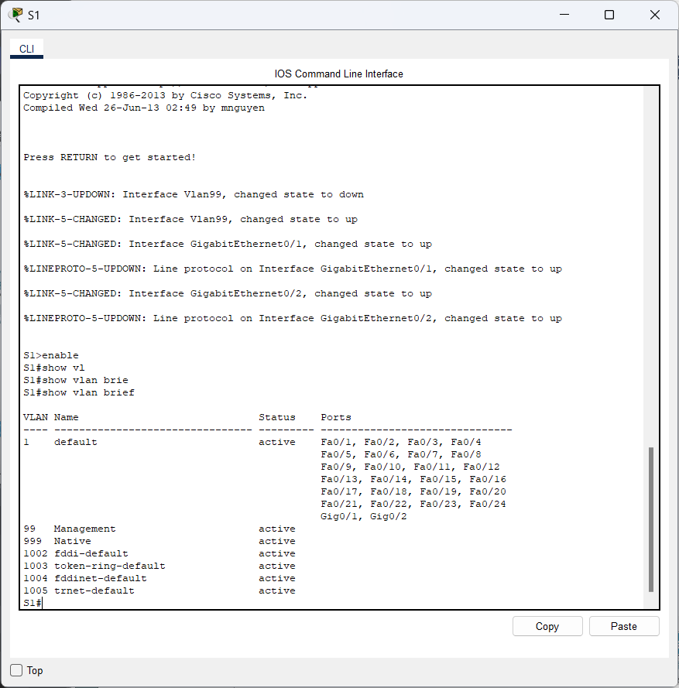

1. Repeat Step 1a on S2 and S3.

**Answer:**

* **S2**

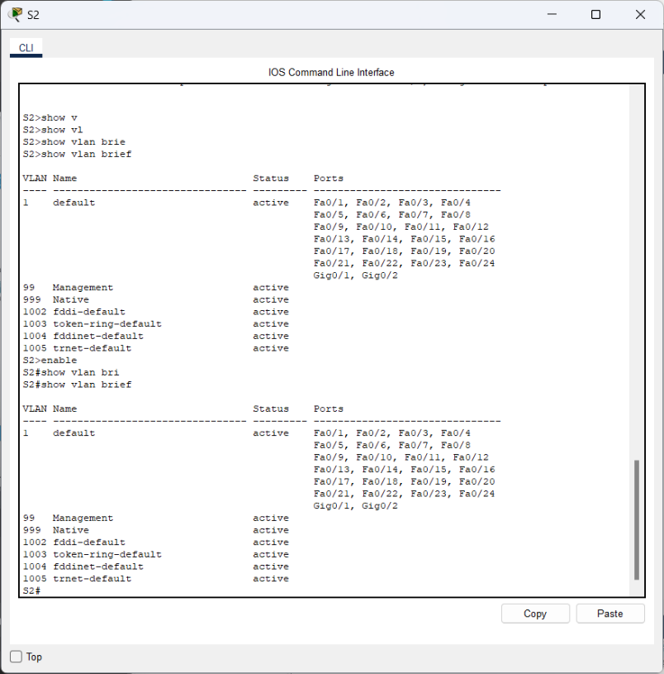

* **S3**

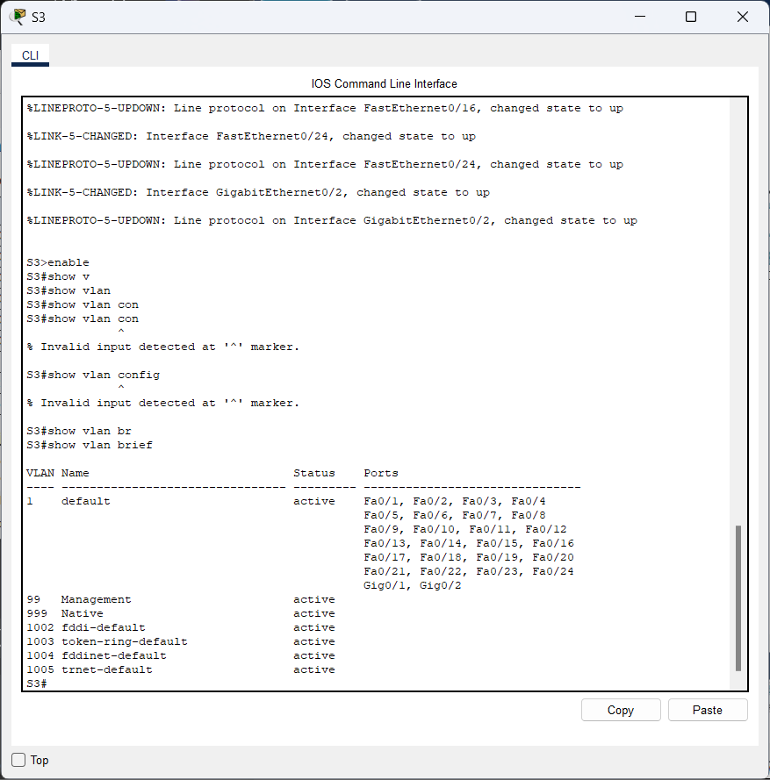

What VLANs are configured on the switches?

**Answer:**

Di antara 3 switches mereka telah dikonfigurasi 99 untuk management dan 999 untuk native vlan.

**Part 2: Create additional VLANs on S2 and S3.**

1. On S2, create VLAN 10 and name it Red.

S2(config)# **vlan 10**

S2(config-vlan)# **name Red**

**Answer:**

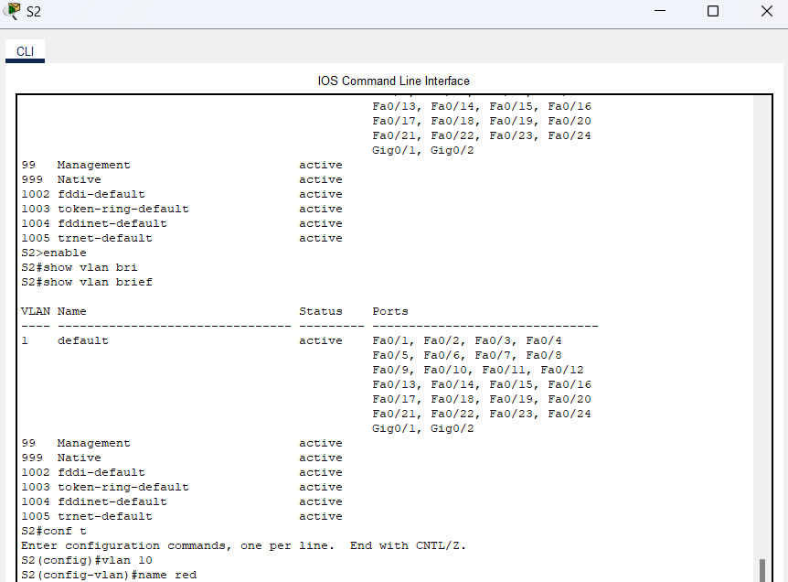

1. Create VLANs 20 and 30 according to the table below.

|  |  |  |
| --- | --- | --- |
| **VLAN Number** |  | **VLAN Name** |
| 10 | Red |  |
| 20 | Blue |  |
| 30 | Yellow |  |

**Answer:**

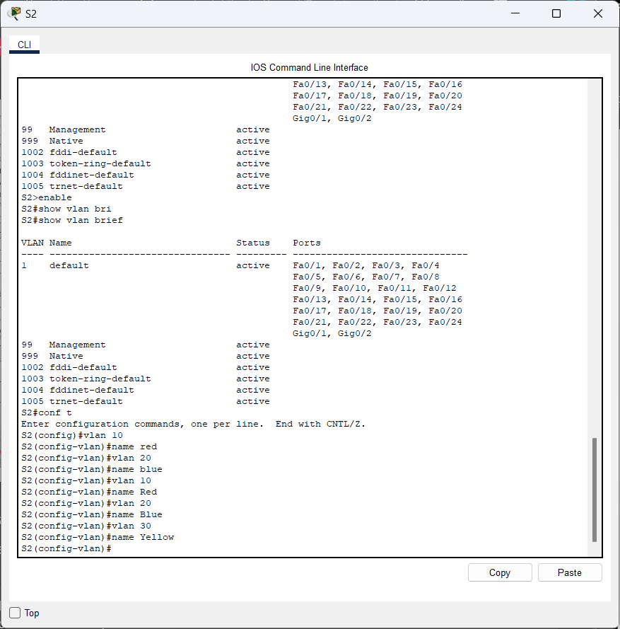

1. Verify the addition of the new VLANs. Enter **show vlan brief** at the privileged EXEC mode.

**Answer:**

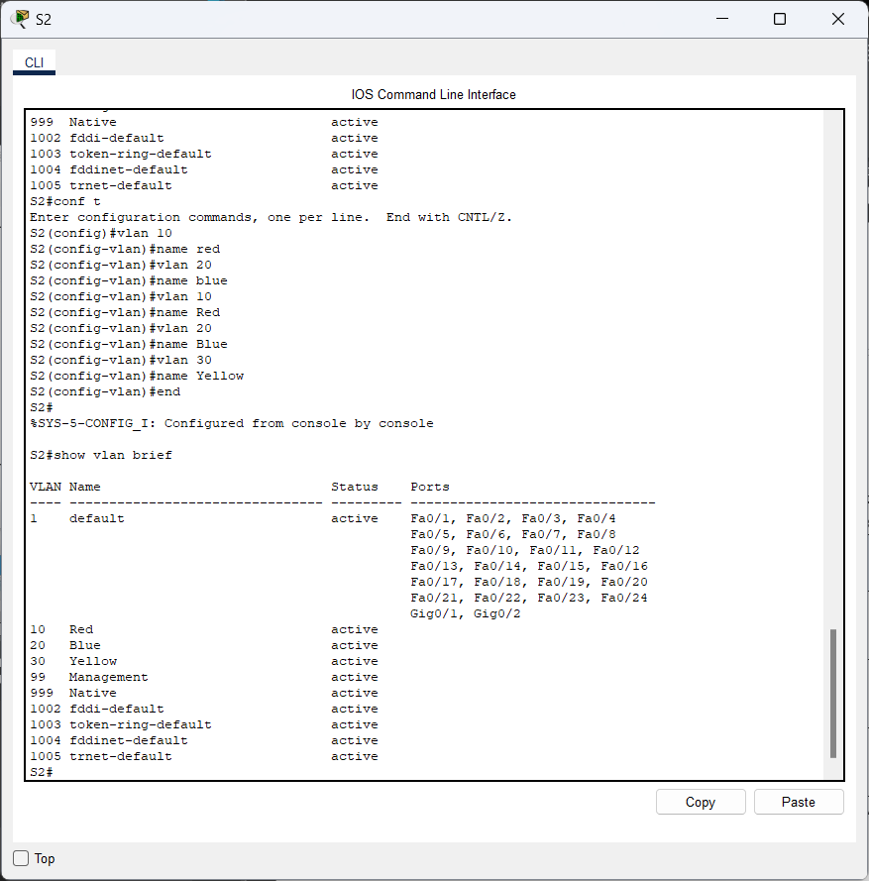

Question:

In addition to the default VLANs, which VLANs are configured on S2?

**Answer:**

VLAN 10 (Red), VLAN 20 (Blue), VLAN 30 (Yellow), VLAN 99 (Management), and VLAN 999 (Native).

1. Repeat the previous steps to create the additional VLANs on S3.

**Answer:**

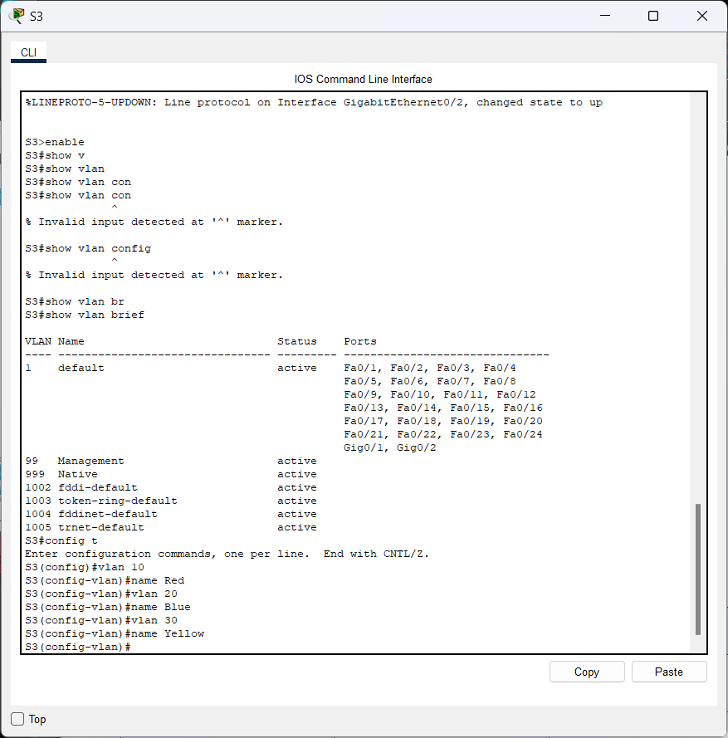

* **Show vlan brief**

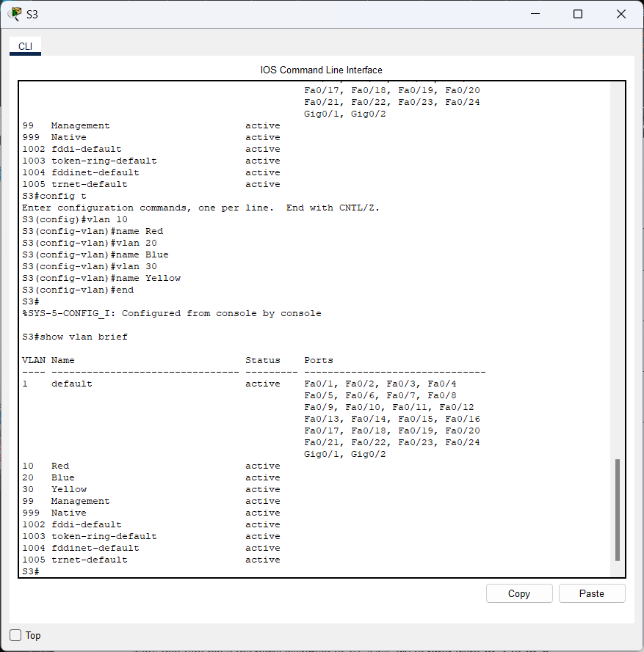

**Part 3: Assign VLANs to Ports**

Use the **switchport mode access** command to set access mode for the access links. Use the **switchport access vlan** *vlan-id* command to assign a VLAN to an access port.

|  |  |  |
| --- | --- | --- |
| **Ports** | **Assignments** | **Network** |
| S2 F0/1 – 8  S3 F0/1 – 8 | VLAN 10 (Red) | 192.168.10.0 /24 |
| S2 F0/9 – 16  S3 F0/9 – 16 | VLAN 20 (Blue) | 192.168.20.0 /24 |
| S2 F0/17 – 24  S3 F0/17 – 24 | VLAN 30 (Yellow) | 192.168.30.0 /24 |

1. Assign VLANs to ports on S2 using assignments from the table above.

S2(config-if)# **interface range f0/1 - 8**

S2(config-if-range)# **switchport mode access**

S2(config-if-range)# **switchport access vlan 10**

S2(config-if-range)# **interface range f0/9 -16**

S2(config-if-range)# **switchport mode access**

S2(config-if-range)# **switchport access vlan 20**

S2(config-if-range)# **interface range f0/17 - 24**

S2(config-if-range)# **switchport mode access**

S2(config-if-range)# **switchport access vlan 30**

**Answer:**

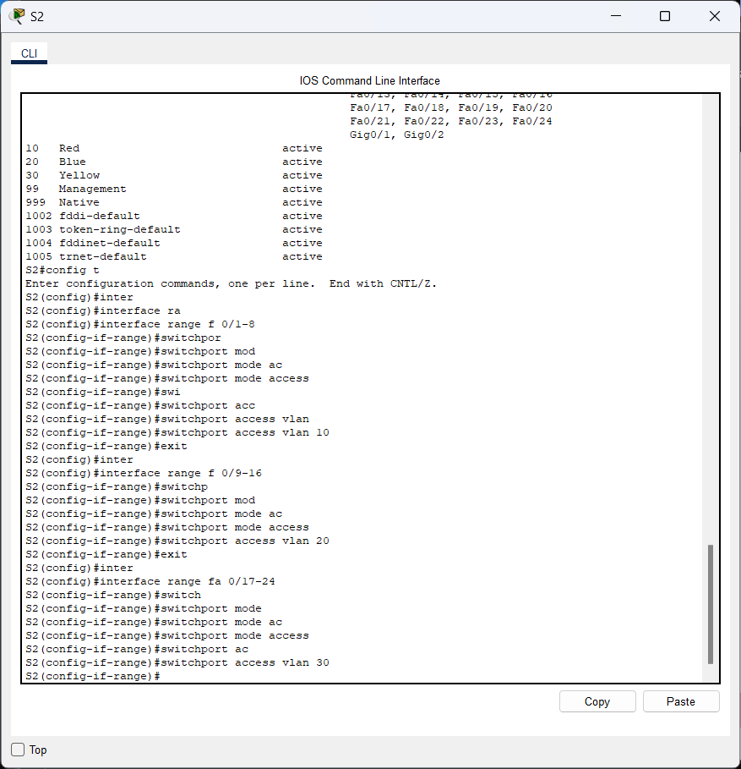

1. Assign VLANs to ports on S3 using the assignments from the table above.

**Answer:**

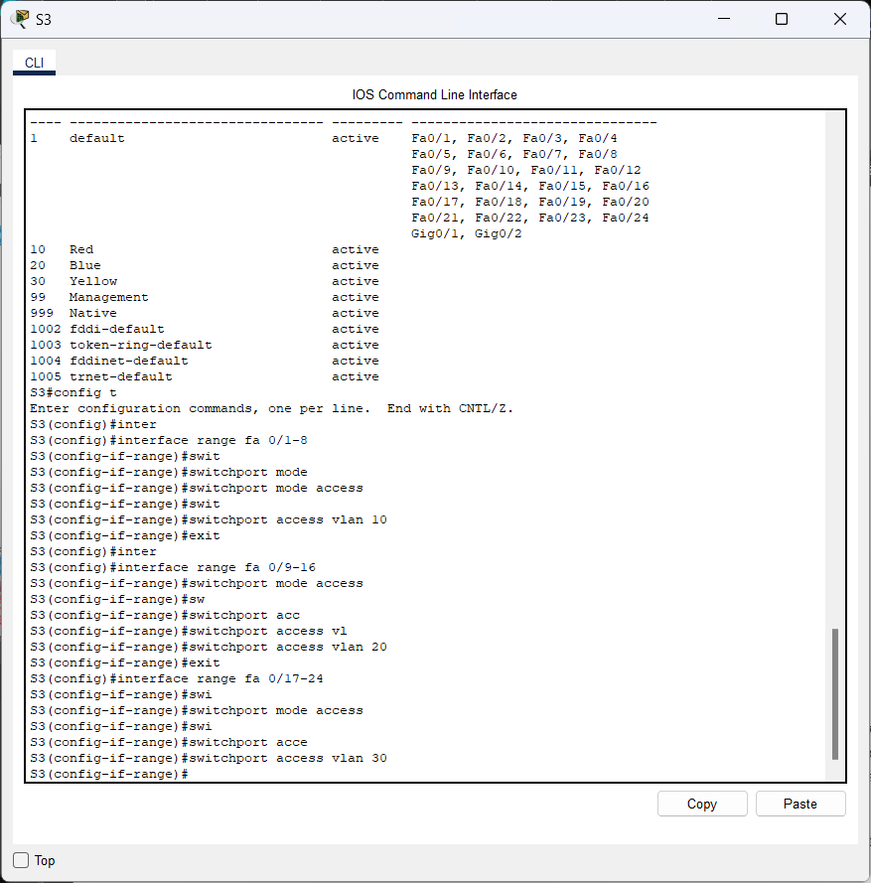

Now that you have the ports assigned to VLANs, try to ping from **PC1** to **PC6**.

**Answer:**

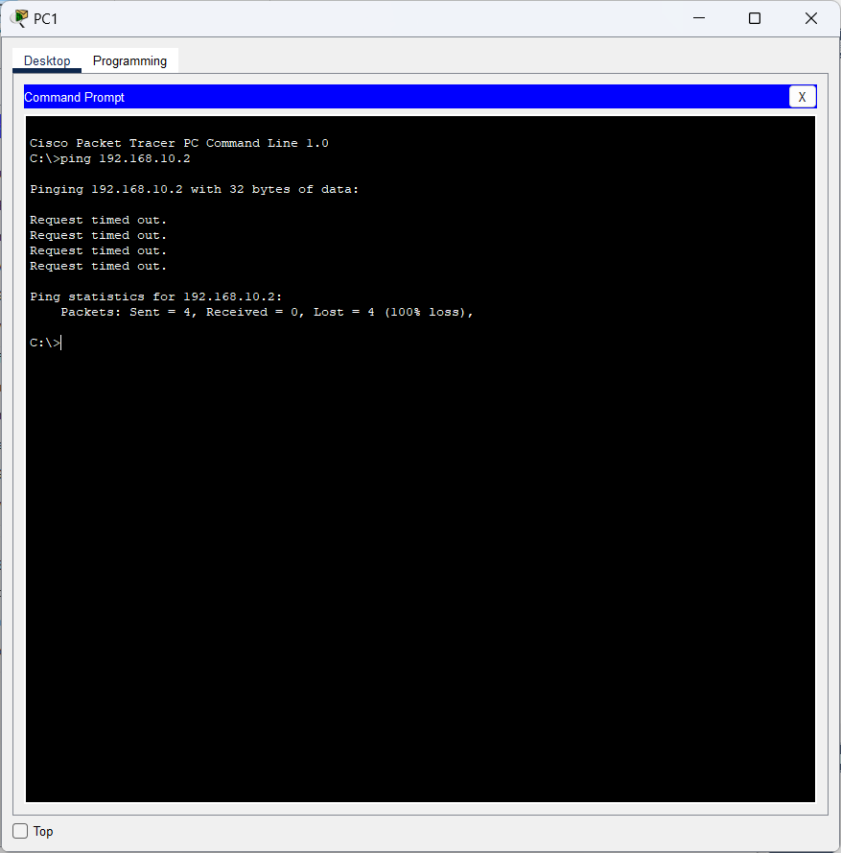

Question:

Was the ping successful? Explain.

**Answer:**

Tidak, ping tersebut gagal karna port itu diantara switch yang mana ada di VLAN 1 dan PC 1 dan PC6 ada di VLAN 10.

***r answers here.***

**Part 4: Configure Trunks on S1, S2, and S3.**

Dynamic trunking protocol (DTP) manages the trunk links between Cisco switches. Currently, all the switchports are in the default trunking mode, which is dynamic auto. In this step, you will change the trunking mode to dynamic desirable for the link between switches S1 and S2. The link between switches S1 and S3 will be set as a static trunk. Use VLAN 999 as the native VLAN in this topology.

1. On switch S1, configure the trunk link to dynamic desirable on the GigabitEthernet 0/1 interface. The configuration of S1 is shown below.

S1(config)# **interface g0/1**

S1(config-if)# **switchport mode dynamic desirable**

**Answer:**

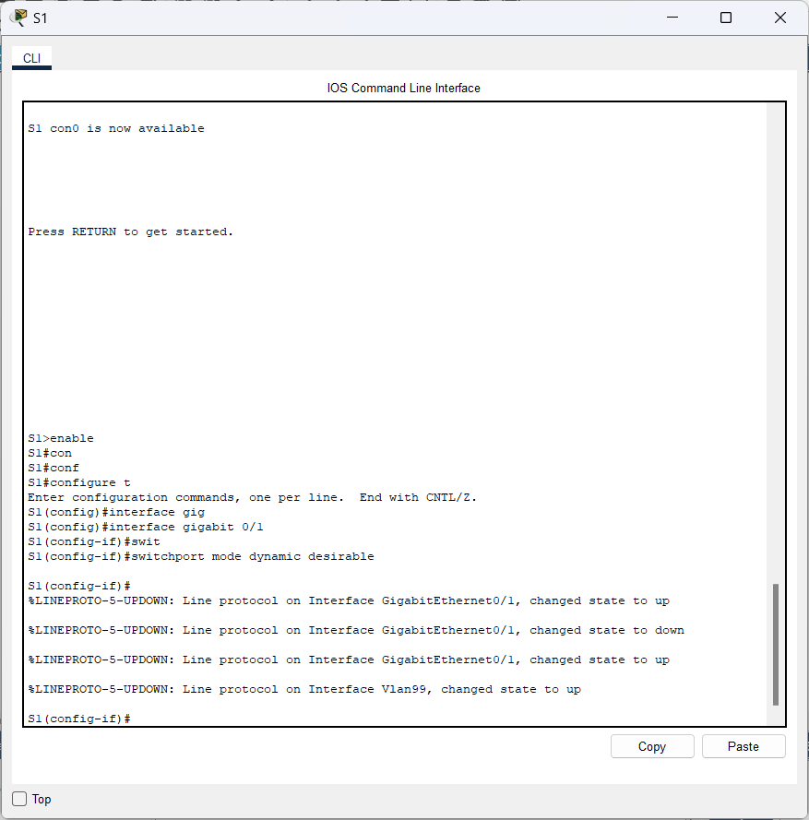

Question:

What will be the result of trunk negotiation between S1 and S2?

**Answer:**

Kaitan dari Trunk sudah didirikan antara S1 dan S2

1. On switch S2, verify that the trunk has been negotiated by entering the **show interfaces trunk** command.

Interface GigabitEthernet 0/1 should appear in the output.

**Answer:**

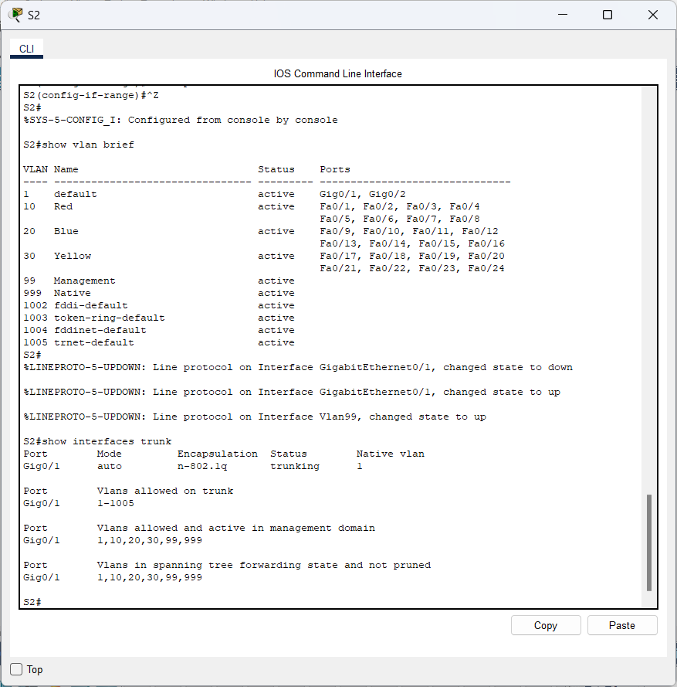

What is the mode and status for this port?

**Answer:**

Mode: Auto

Status: Trunking

1. For the trunk link between S1 and S3, configure interface GigabitEthernet 0/2 as a static trunk link on S1. In addition, disable DTP negotiation on interface G0/2 on S1.

S1(config)# **interface g0/2**

S1(config-if)# **switchport mode trunk**

S1(config-if)# **switchport nonegotiate**

**Answer:**

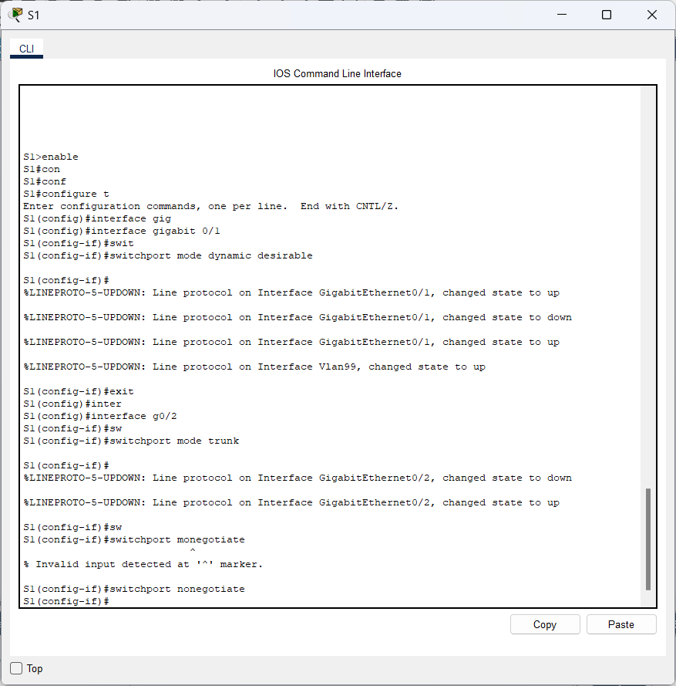

1. Use the **show dtp** command to verify the status of DTP.

S1# **show dtp**

Global DTP information

Sending DTP Hello packets every 30 seconds

Dynamic Trunk timeout is 300 seconds

1 interfaces using DTP

**Answer:**

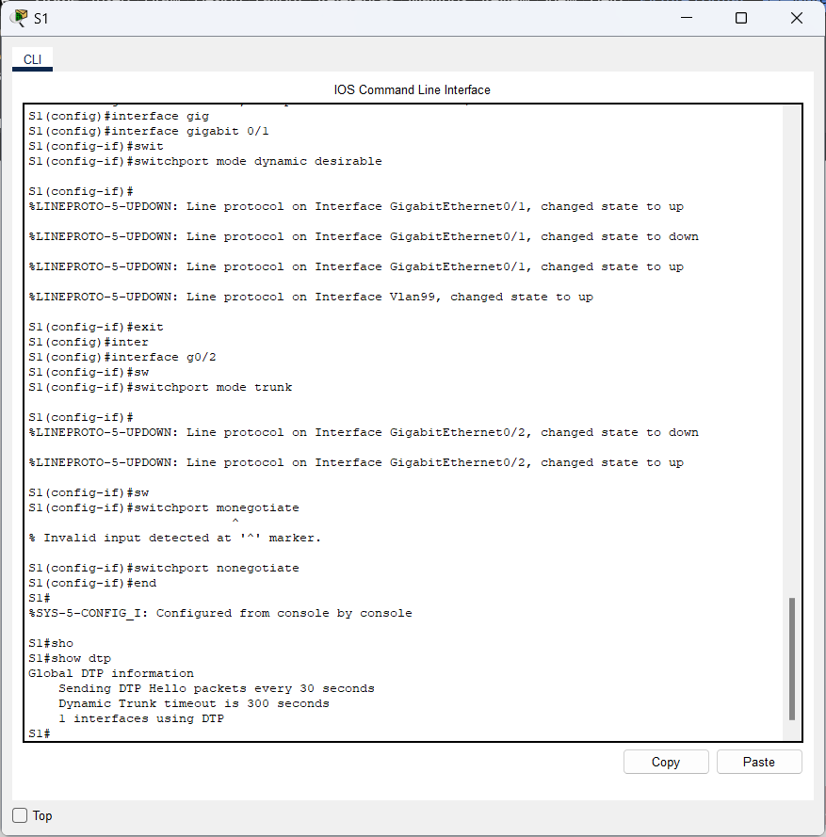

1. Verify trunking is enabled on all the switches using the **show interfaces trunk** command.

S1# **show interfaces trunk**

Port Mode Encapsulation Status Native vlan

Gig0/1 desirable n-802.1q trunking 1

Gig0/2 on 802.1q trunking 1

Port Vlans allowed on trunk

Gig0/1 1-1005

Gig0/2 1-1005

Port Vlans allowed and active in management domain

Gig0/1 1,99,999

Gig0/2 1,99,999

Port Vlans in spanning tree forwarding state and not pruned

Gig0/1 1,99,999

Gig0/2 1,99,999

**Answer:**

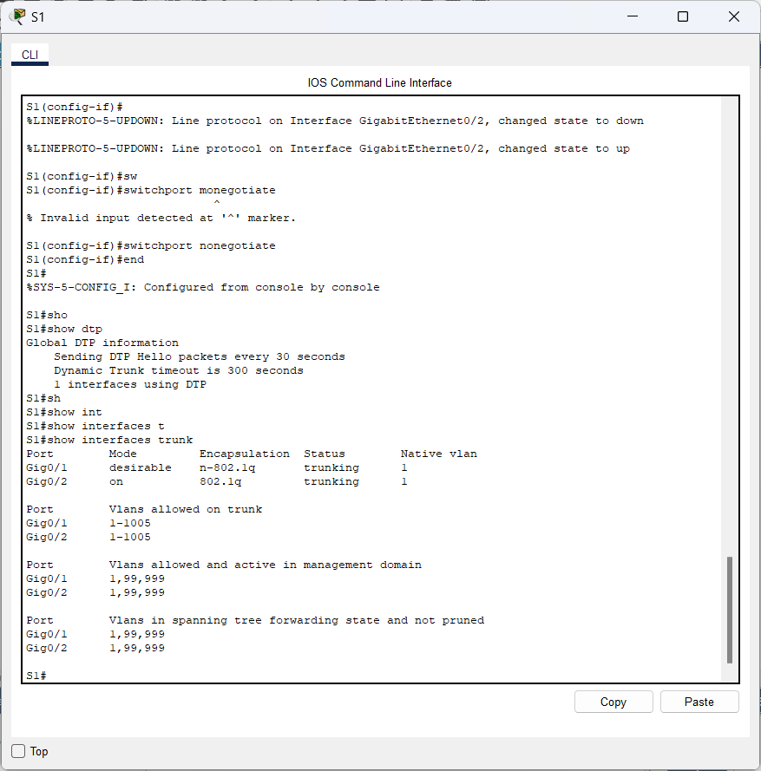

Question:

What is the native VLAN for these trunks currently?

**Answer:**

The native VLAN is VLAN 1 ***answers here.***

1. Configure VLAN 999 as the native VLAN for the trunk links on S1.

S1(config)# **interface range g0/1 - 2**

S1(config-if-range)# **switchport trunk native vlan 999**

Question:

**Answer:**

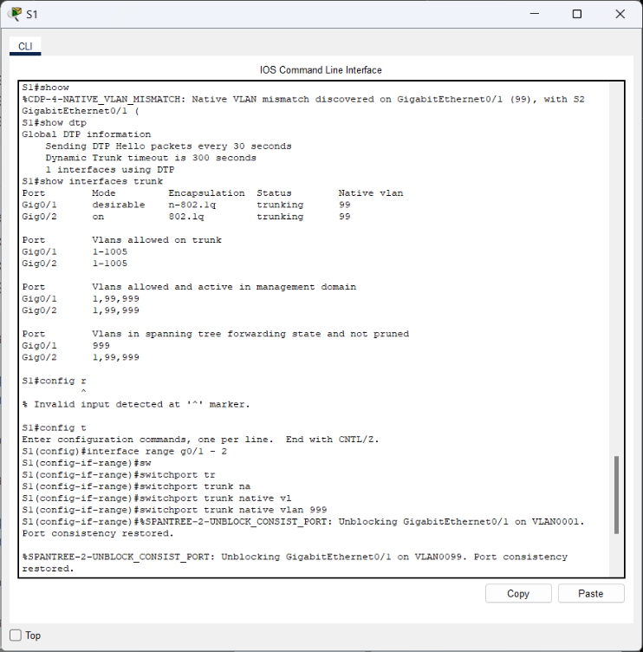

What messages did you receive on S1? How would you correct it?

**Answer:**

Untuk memperbaiki ketidakcocokan pada VLAN Native, konfigurasikan VLAN 999 sebagai VLAN asli pada S2 dan S3.***wers here.***

1. On S2 and S3, configure VLAN 999 as the native VLAN.

**Answer:**

* **S2**

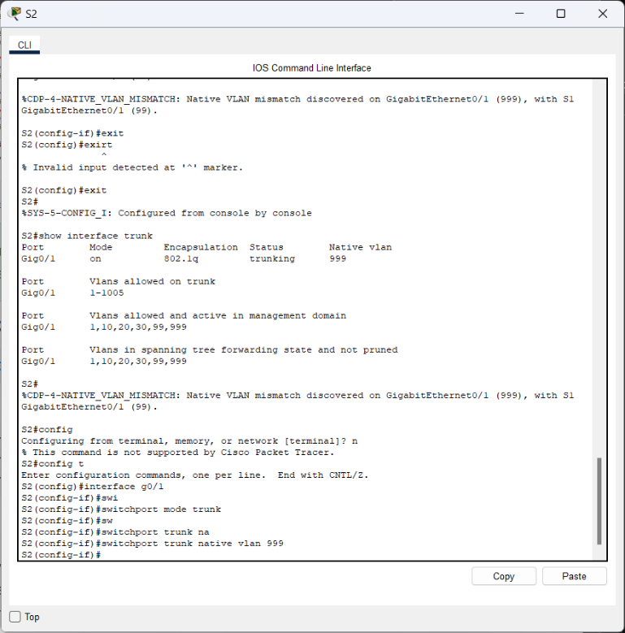

* **S3**

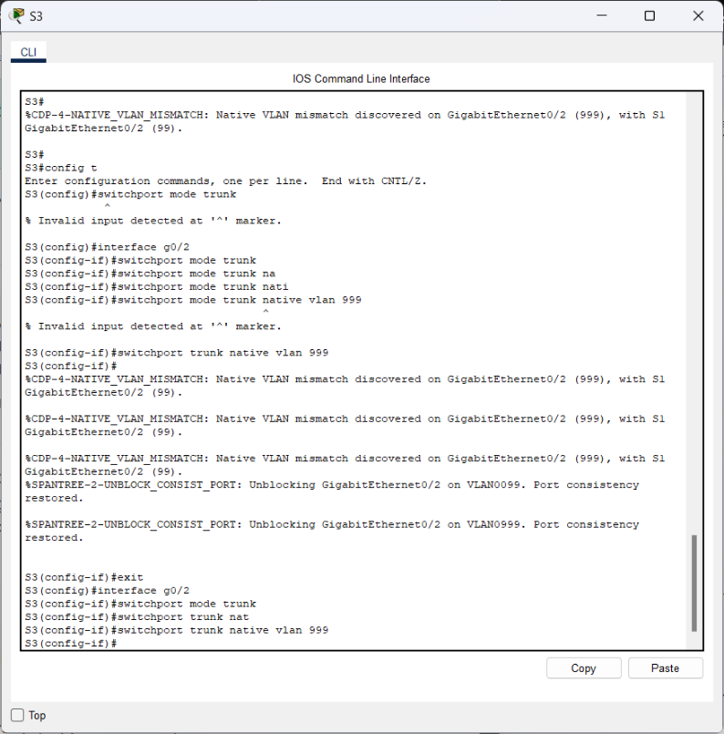

1. Verify trunking is successfully configured on all the switches. You should be able ping one switch from another switch in the topology using the IP addresses configured on the SVI.

**Answer:**

* **Ping S1 ke S2**

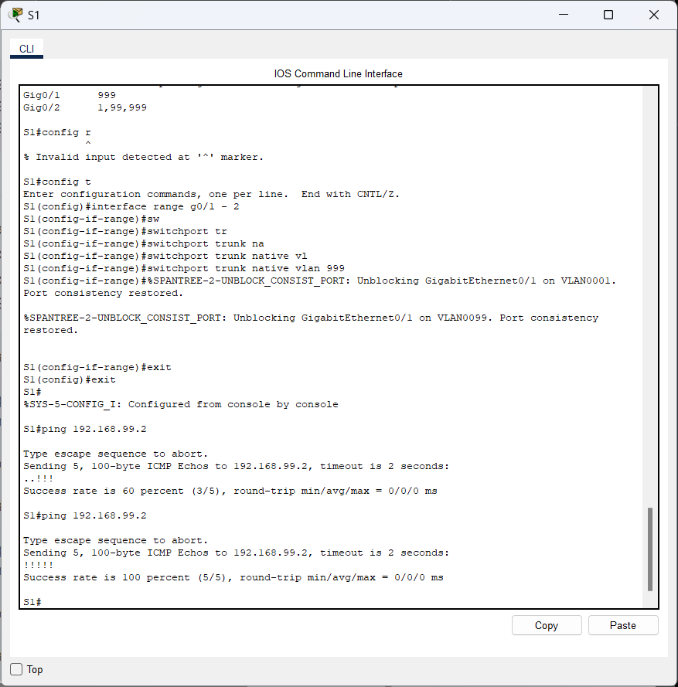

* **Ping S1 ke S3**

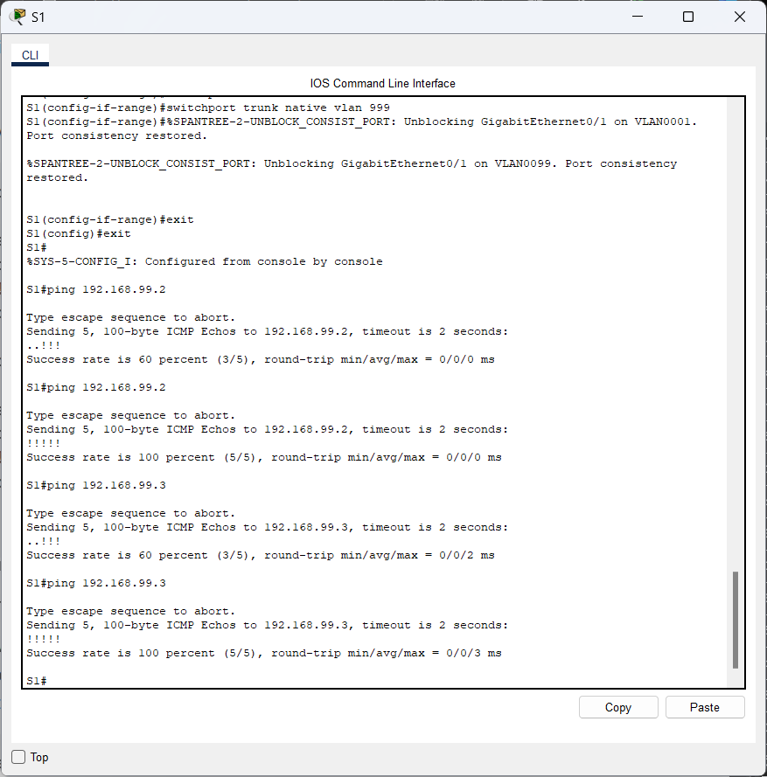

1. Attempt to ping from PC1 to PC6.

**Answer:**

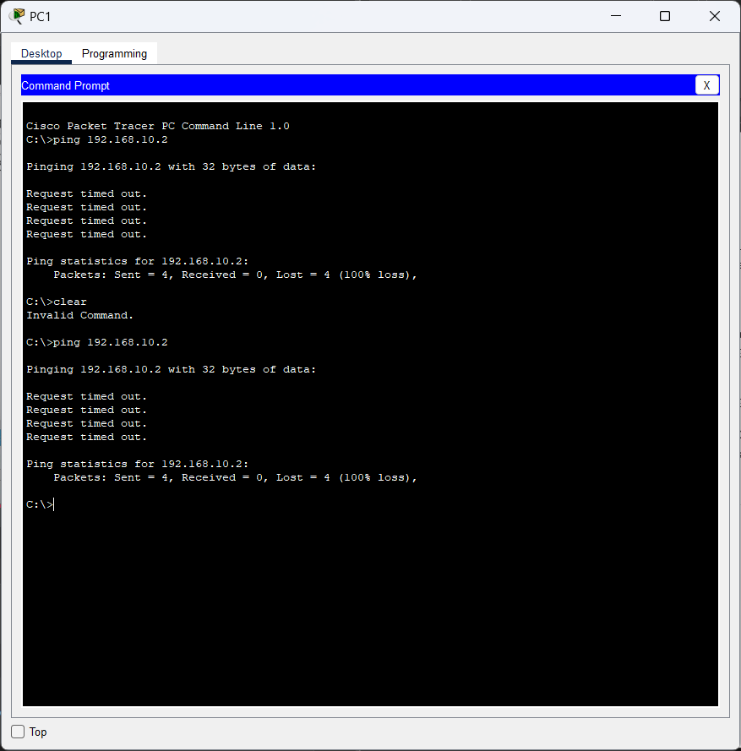

Question:

Why was the ping unsuccessful? (Hint: Look at the ‘**show vlan brief**’ output from all three switches. Compare the outputs from the ‘**show interface trunk**’ on all switches.)

**Answer:**

***s***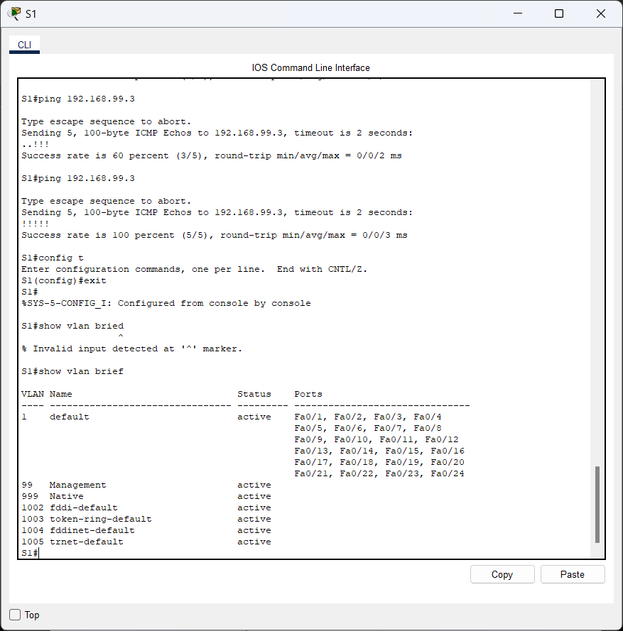

* **Mengkonfigurasikan vlan Red, Blue dan Yellow**

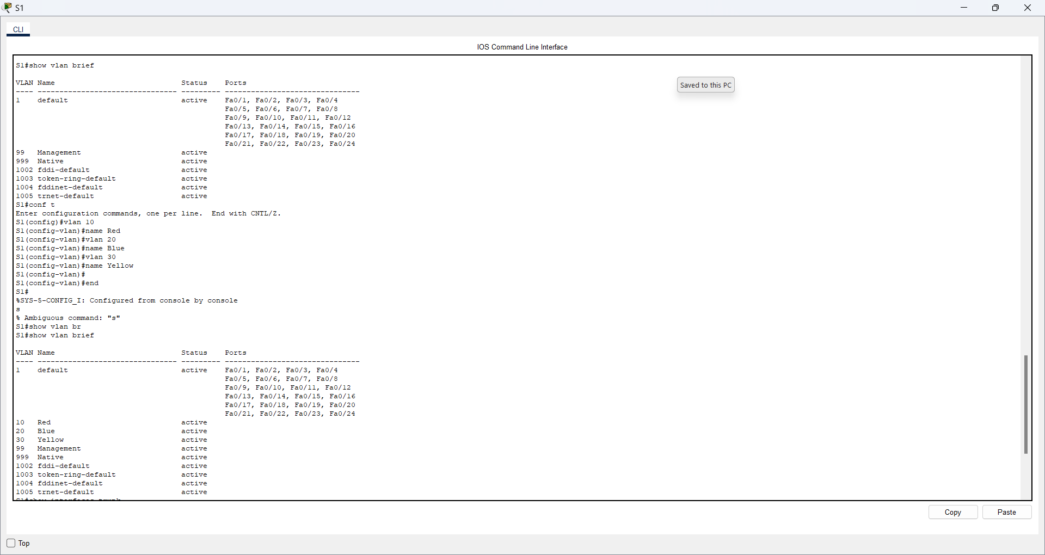

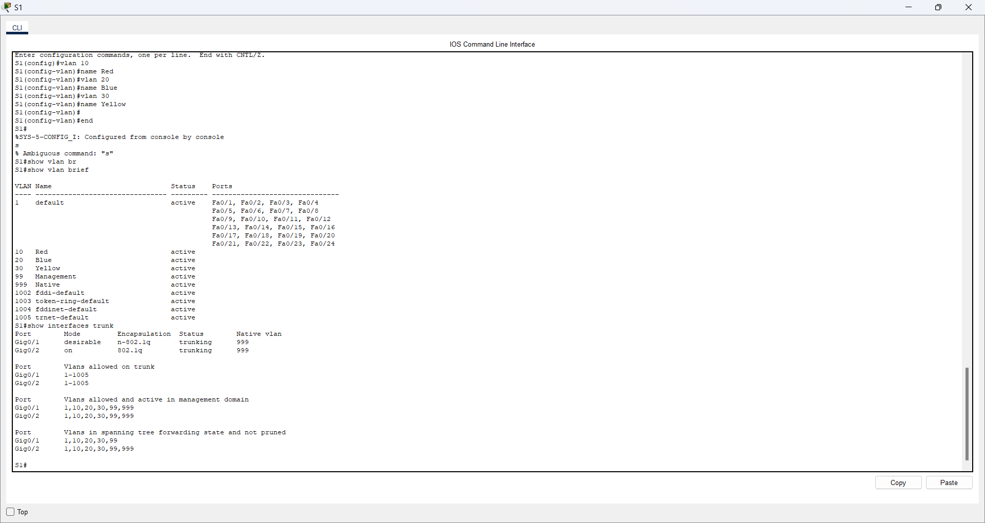

1. Correct the configuration as necessary.

**Part 5: Reconfigure trunk on S3.**

1. Issue the ‘**show interface trunk**’ command on **S3**.

**Answer:**

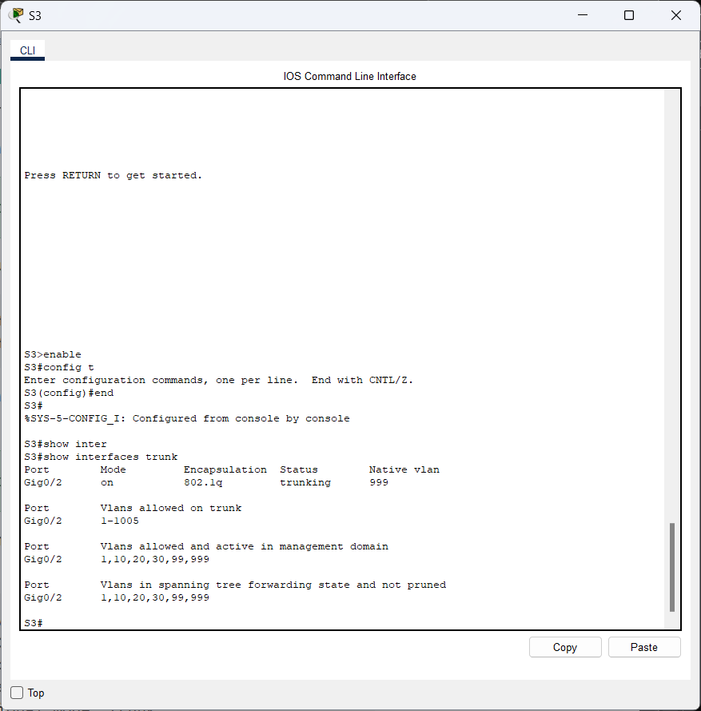

Question:

What is the mode and encapsulation on G0/2?

**Answer:**

Mode: On

Encapsultion: 802.1q

***Type your answers here.***

1. Configure **G0/2** to match **G0/2** on **S1**.

**Answer:**

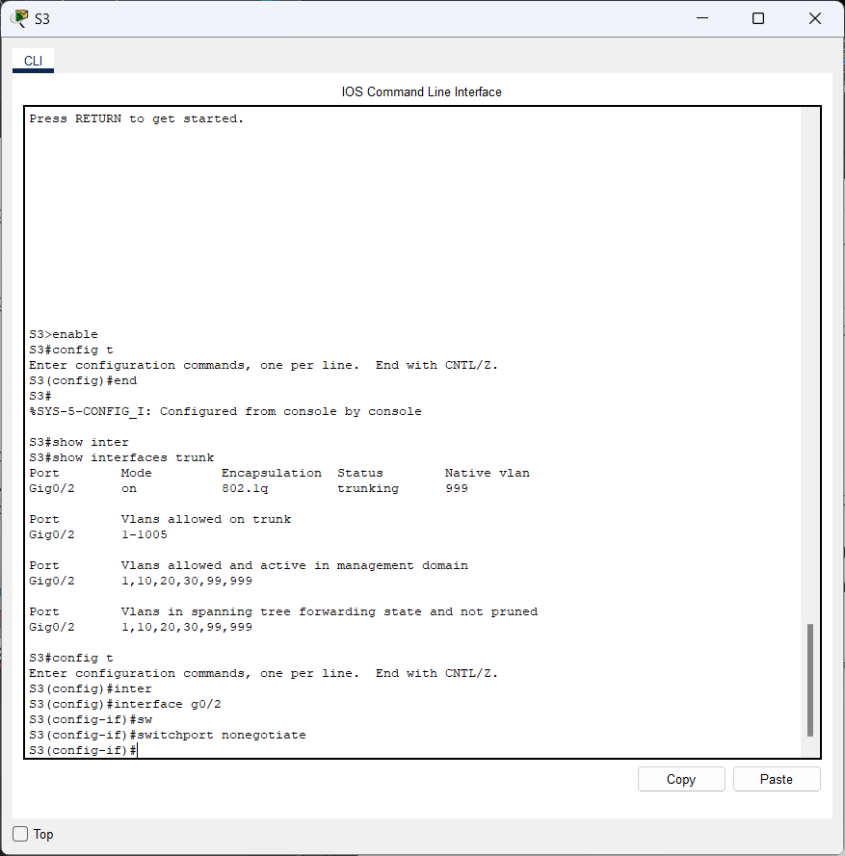

Question:

What is the mode and encapsulation on G0/2 after the change?

**Answer:**

Mode: On

Encapsulation: 802.1q

***Type your answers here.***

1. Issue the command ‘**show interface G0/2 switchport**’ on switch **S3**.

**Answer:**

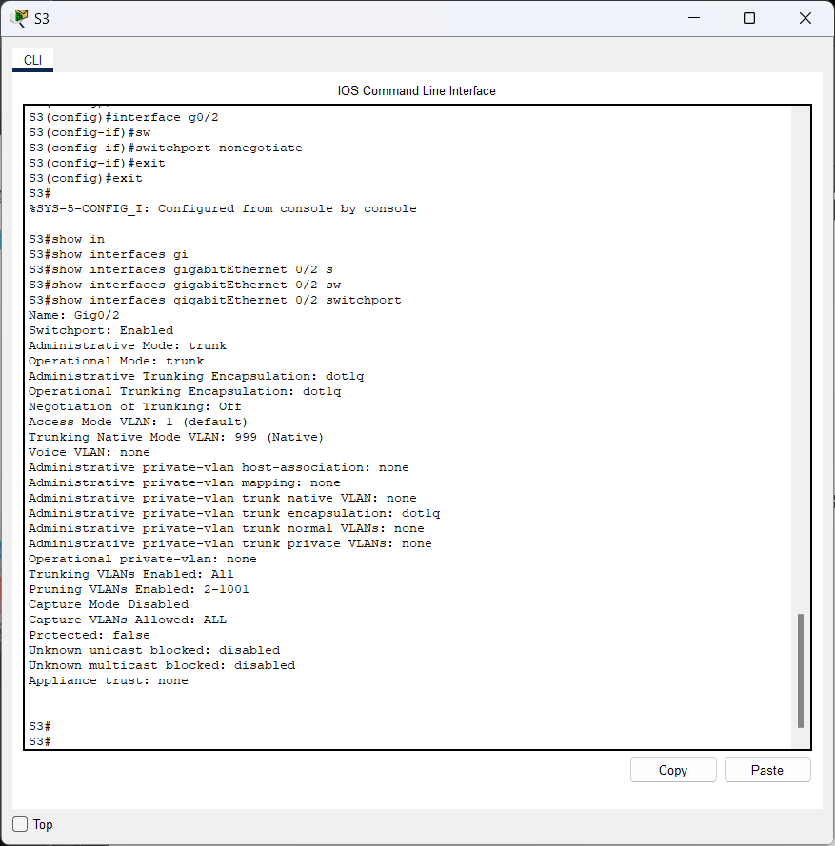

Question:

What is the ‘**Negotiation of Trunking**’ state displayed?

**Answer:**

The Negotiation of Trunking state is Off.

**Part 6: Verify end to end connectivity.**

1. From PC1 ping PC6.

**Answer:**

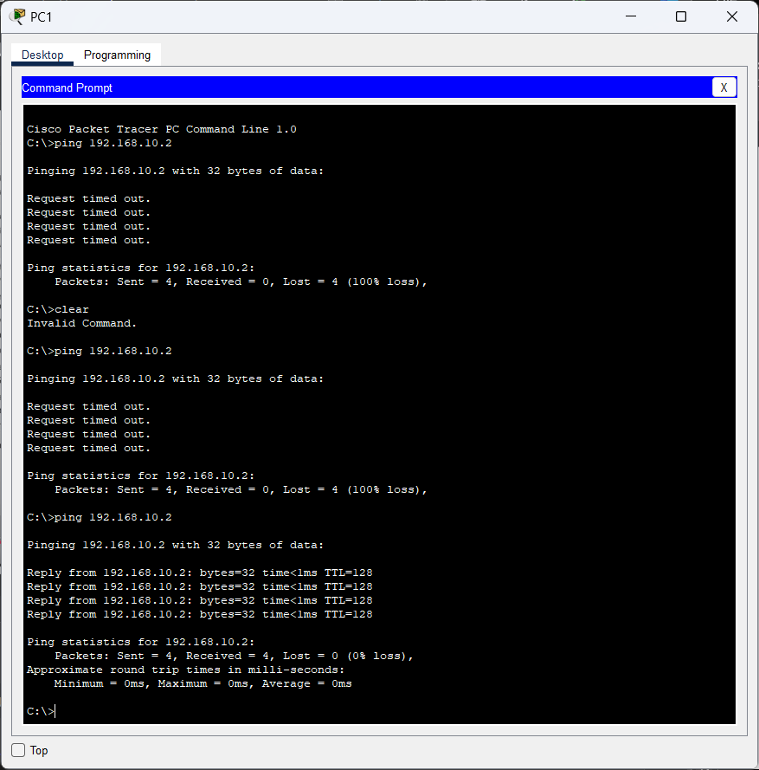

1. From PC2 ping PC5.

**Answer:**

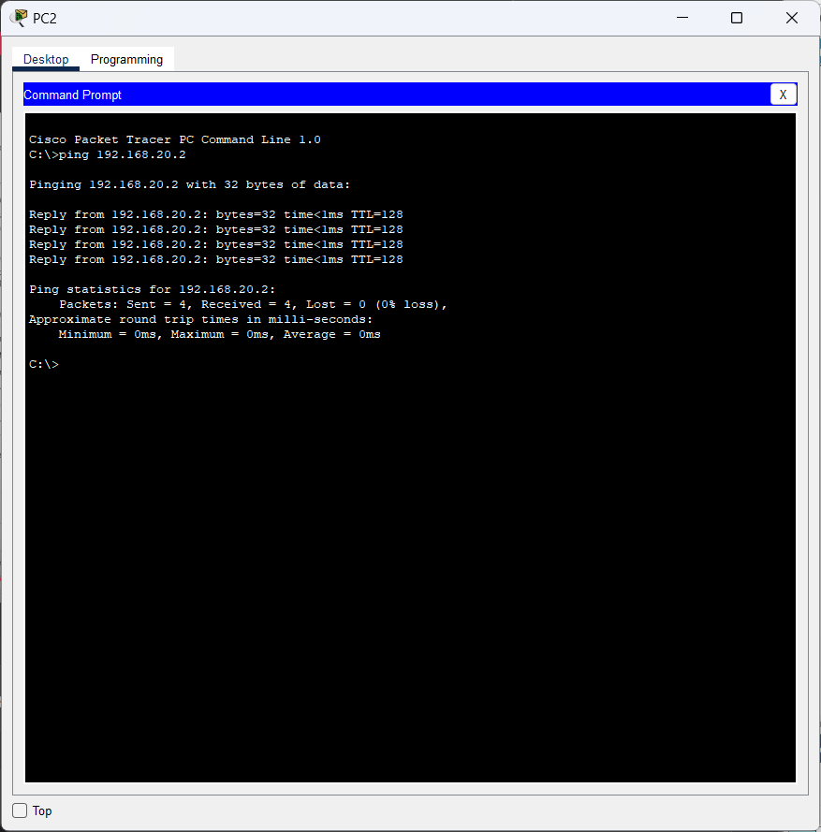

1. From PC3 ping PC4.

**Answer:**

